Wednesday, July 17, 2018
Stampede Kick Off (Charles Street E.)
Brought to you by the Morris Chamber of Commerce

Thursday, July 18, 2019 Schedule of Events
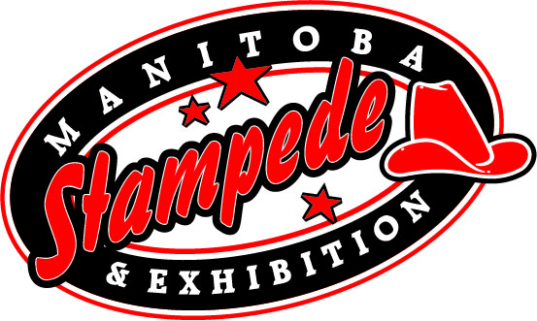
Free Gate Admission All day

Sponsor of the Day: Trans Canada Brewing Co.

10:00am -Gathering of Nations (open till dusk)
-Pony Rides (till 8pm East Show Barn)
-Ag-Tivity Ranch (open till 7pm: Giggle Creations Face Painting)
-Beer Gardens (open till 1am)
-RAD Equine – Equine Therapies (till 6pm West Show Barn)
10:30am -Puff the Clown (Ag-tivity Ranch)
-Livestock Experiences and Displays (open till 9pm, West Show Barn)
- Petting Zoo (open till 9pm, West Show Barn)
11:00am -School Work and Historical Centre (North Orange Barn)
-Outdoor Vendors (Open till 10pm)
1:00pm -Bubbleman (Ag-Tivity Ranch)
-Indoor Trade Show (Open till 9, Morris Multiplex)
2:00pm -World Championship Pony Chuckwagon & Chariot Racing (Main Grandstands)
Featuring the Special Act Hawreluik Racing Group (Main Grandstands)
-Midway Opens
4:00pm -Gymkhana Registration (Show Ring, till 8pm)
-Puff the Clown (Ag-Tivity Ranch) 7:00pm -Manitoba’s Only Professional Rodeo (Main Grandstands)
Featuring: Bareback, SaddleBronc, Steer Wrestling, Tie Down Roping, Ladies Barrel Racing , Team Roping, Bull Riding, Manitoba Mutton Bustin’, & Tyson Wagner, Rodeo Clown
9:00pm -SEAN BURNS Band (till 1:00 am Rempel Insurance Saloon Stage)

TBA -Pipe Ceremony Opening

