Sunday, July 21 2019 Schedule of Events
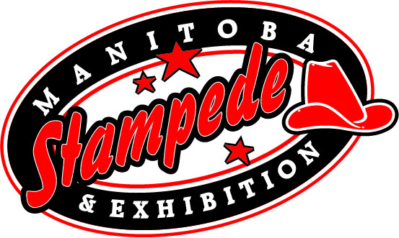
Free Gate Admission All Day

Sponsor of the Day: R.M. of Morris

9:00am -MB team Penning (West Show Ring)
10:00am -Gathering of Nations (till 6pm)
-Pony Rides (till 7pm, East Show Barn)
-Beer Gardens (Open till 1am)
-Multi-Church Community Stampede Service (Main Grandstand)
-Ag-Tivity Ranch (open till 3pm: Giggle Creations Face Painting)
10:30am -Livestock Experiences and Displays (open till 7pm, West Show Barn)
- Petting Zoo (open till 7pm, West Show Barn)
11:00am -X-Treme Dogs (East Show Ring)
-School Work and Historical Centre (North Orange Barn)
-Indoor Trade Show (Open till 6pm, Morris Multiplex)
-Outdoor Vendors (Open till 7pm)
12:00pm -Midway Opens (till 6)
-SULIAT Band (Rempel Insurance Saloon Stage)
1:00pm -Pat Covernton Album Release Party (Rempel Insurance Saloon Stage)
2: 00pm -Manitoba’s Only Professional Rodeo (Main Grandstands
Featuring: Bareback, SaddleBronc, Steer Wrestling, Tie Down Roping, Ladies
Barrel Racing, Team Roping, Bull Riding, Manitoba Mutton Bustin’, & Tyson Wagner Rodeo Clown
-World Championship Pony Chuckwagons & Chariot Races, (Main Grandstands)
Featuring the Special Act Hawreluik Racing Group (Main Grandstands)
3:30pm -X-Treme Dogs

