Saturday, July 20, 2019 Schedule of Events
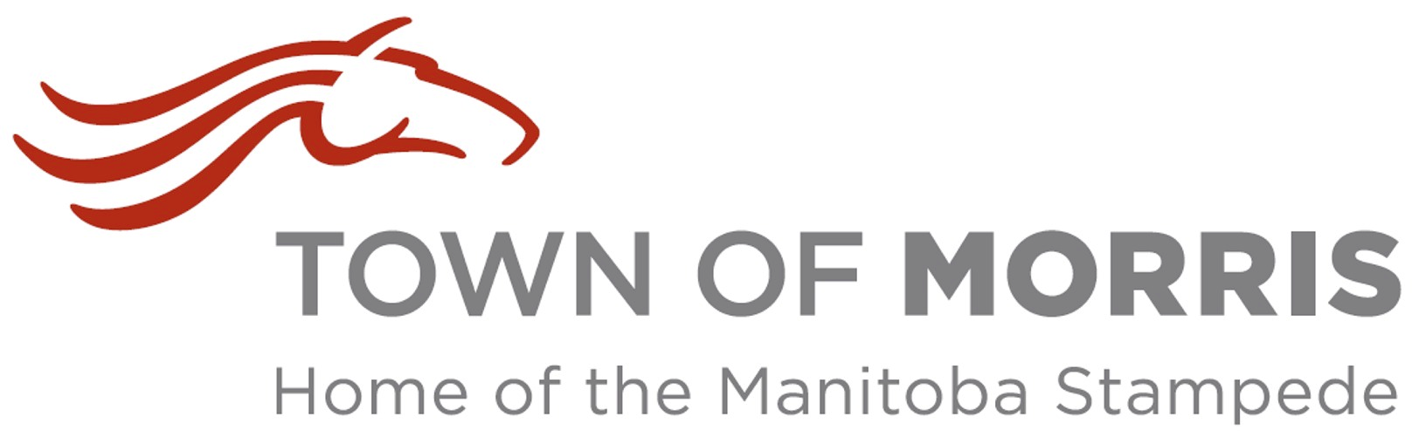
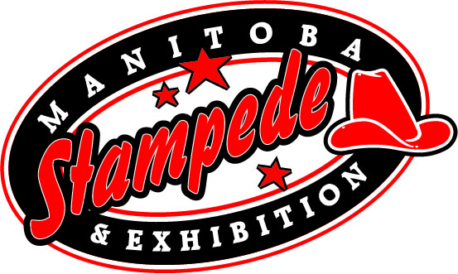
Free Gate Admission All Day

Sponsor of the Day: Town of Morris

9:00am -MB Team Penning (till 6pm, West Show Ring)
10:00am -The Manitoba Stampede and Exhibition Parade (Lucinda Street, Morris, 1
Block west of Main Street)
-Gathering of Nations Displays (Open till Dusk)
-Pony Rides (till 8pm, East Show Barn)
-Beer Gardens (Open till 1am)
-MB Stock Dog Trial Finals (till 2pm, East Show Ring)
10:30am -Puff the Clown (Ag-Tivity Ranch)
-Livestock Experiences and Displays (open till 9pm, West Show Barn)
- Petting Zoo (open till 9pm, West Show Barn)
11:00am -Hutlet 2.0 (Sweet Grass Stage)
-RainDrop Equine Therapy Demonstration (till 12:30, Light House Barn)
-School Work and Historical Centre (North Orange Barn)
-Outdoor Vendors (Open till 10pm)
-Indoor Trade Show (Open till 10pm, Morris Multiplex)
-Ag-Tivity Ranch
12:00pm -Midway Opens
1:00pm -Bubbleman (Ag-Tivity Ranch)
2:00pm -Manitoba’s Only Professional Rodeo (Main Grandstands)
Featuring: Bareback, SaddleBronc, Steer Wrestling, Tie Down Roping, Ladies
Barrel Racing, Team Roping, Bull Riding, Manitoba Mutton Bustin’, & Tyson
Wagner Rodeo Clown
3:00pm -Northern Lights Drill Team (East Show Ring)
4:00pm -Puff the Clown (Ag-Tivity Ranch)
4:00pm-6:00pm -BIG CITY FILTER Band (Rempel Insurance Saloon Stage)
4:30pm -Hutlet 2.0 (Sweet Grass Stage)
6:00pm - Northern Lights Drill Team (East Show Ring)
7:00pm -World Championship Pony Chuckwagons & Chariot Races (Main Grandstands)
Featuring Hawreluik Racing Group (Main Grandstands)
9:00pm-1:00am -DAVID PESTRAK Band (Rempel Insurance Saloon Stage)

TBA -Pow Wow Showcase Dancer and Drummers
TBA -Bill Crampton Indigenous Teachings

