Friday, July 19, 2019 Schedule of Events
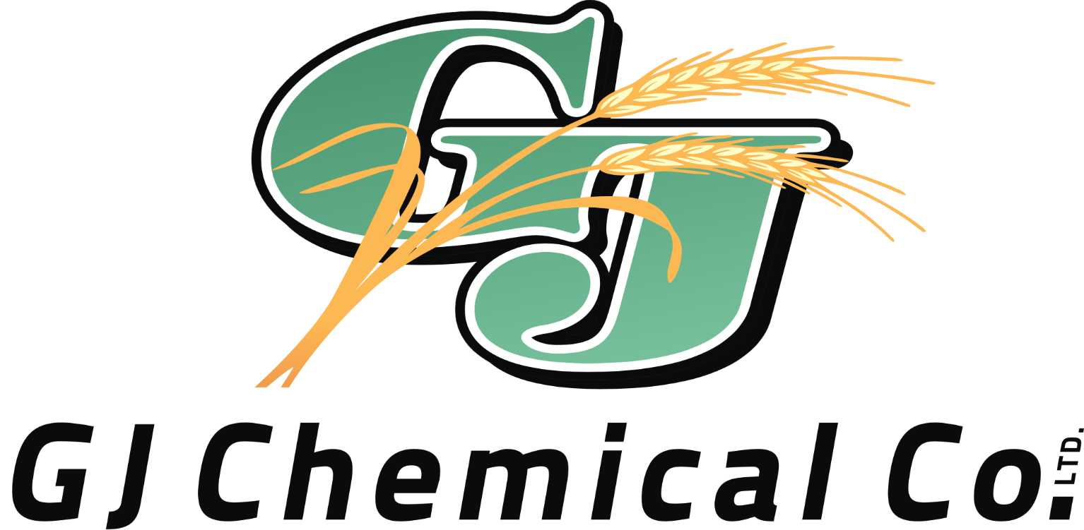
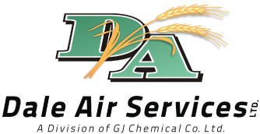
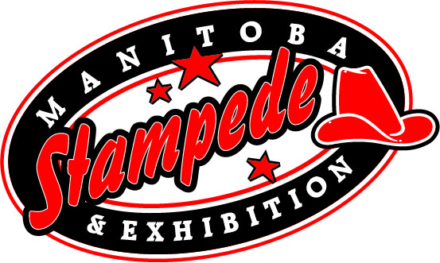
Free Gate Admission All Day

Sponsor of the Day: GJ Chemical Co. / Dale Air Service

7:30am -Free Pancake Breakfast (till 10:30am, Access Credit Union)
10:00am -Gathering of Nations (Open till Dusk)
-Pony Rides (till 8pm, East Show Barn)
-Ag-Tivity Ranch (open till 7pm: Giggle Creations Face Painting)
-Beer Gardens (Open till 1am)
-RAD Equine- Equine Therapy (Open till 6pm, West Show Barn)
10:30am -Puff the Clown (Ag-tivity Ranch)
-Livestock Experiences and Displays (open till 9pm, West Show Barn)
- Petting Zoo (open till 9pm, West Show Barn)
11:00am -School Work and Historical Centre (Orange Barn)
-Outdoor Vendors (Open till 10pm)
12:00pm -Northern Light Drill Team (East Show Ring)
-Ivan Flett Memorial Dancers (Gathering of Nations)
1:00pm -Northern Lights Drill Team (East Show Ring)
-Ivan Flett memorial Dancers (Gathering of Nations)
-Bubbleman (Ag-Tivity Ranch)
-Indoor Trade Show (Open till 10pm, Morris Multiplex
1:45pm -Ivan Flett Memorial Dancers (Sweet Grass Stage)
2:00pm -World Championship Pony Chuckwagons & Chariot Races (Main Grandstands)
Featuring the Special Act Hawreluik Racing Group (Main Grandstands)
-Midway Opens
3:00pm -Northern Lights Drill Team (East Show Ring)
-Ivan Flett Memorial Dancers (Sweet Grass Stage)
4:00pm -Ivan Flett Memorial Dancers (Gathering of the Nations)
-MB Stock Dog Trail (till 7pm, East Show Ring)
-Puff the Clown (Ag-Tivity Ranch)
6:00pm -Ivan Flett Memorial Dancers (Gathering of Nations)
7:00pm - Manitoba’s Only Professional Rodeo (Main Grandstands)
Featuring: Bareback, SaddleBronc, Steer Wrestling, Tie Down Roping, Ladies Barrel Racing, Team Roping, Bull Riding, Manitoba Mutton Bustin’, & Tyson Wagner Rodeo Clown
9:00pm-12:30am -LAS DIVAS! Band (Rempel Insurance Saloon Stage)

TBA -Two Man Ranch Sorting Show (West Show Ring)

